**Code Splitting**

**What is Code Splitting?**

**Code splitting** is a technique in modern web development that involves breaking down a large JavaScript bundle into smaller, more manageable pieces or chunks. These chunks can then be loaded on-demand, meaning that instead of loading a large single file at once, only the necessary code is loaded as needed. This improves the page load time and overall performance, especially for large web applications.

Code splitting a function

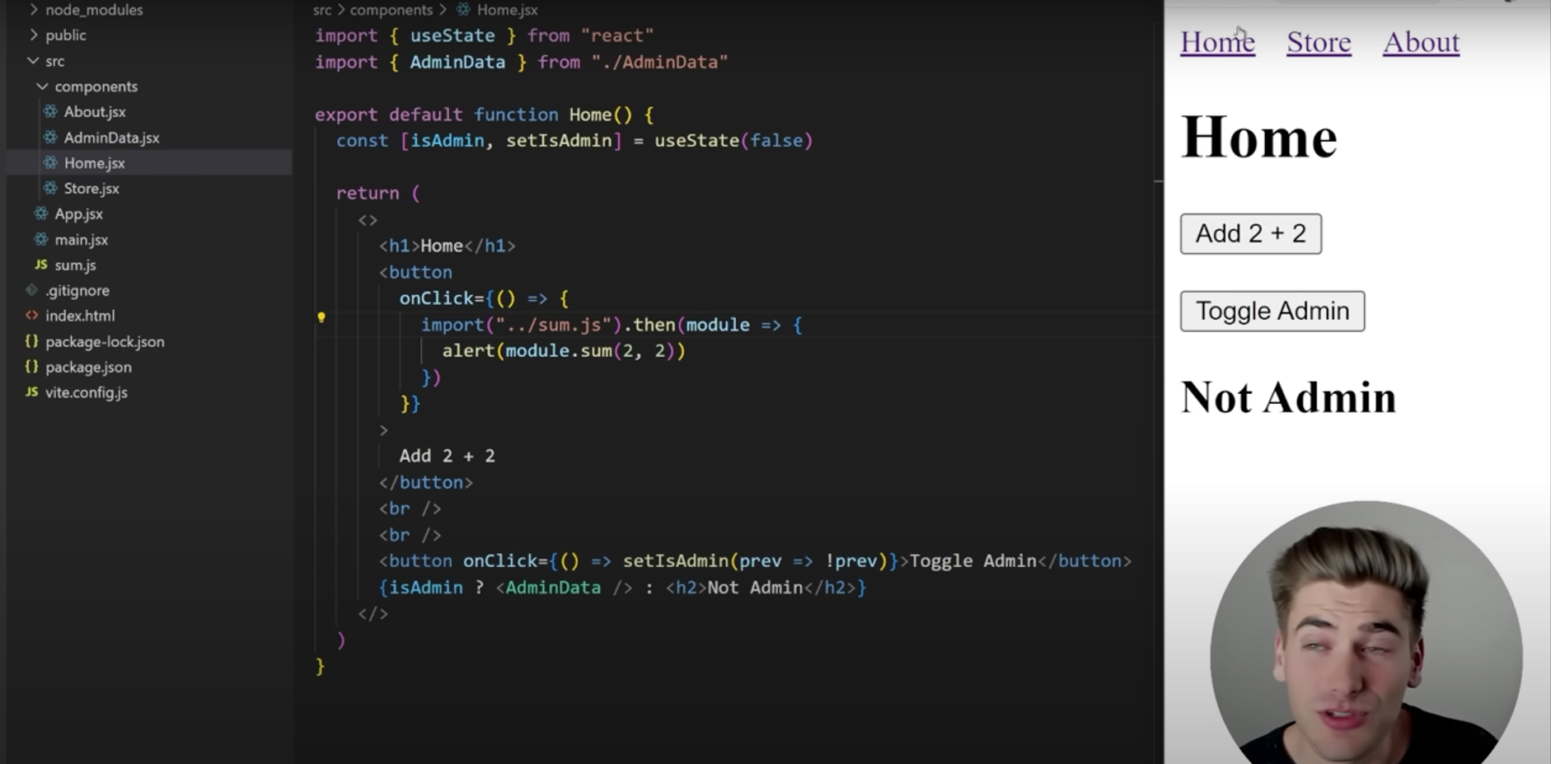

Code splitting a Components

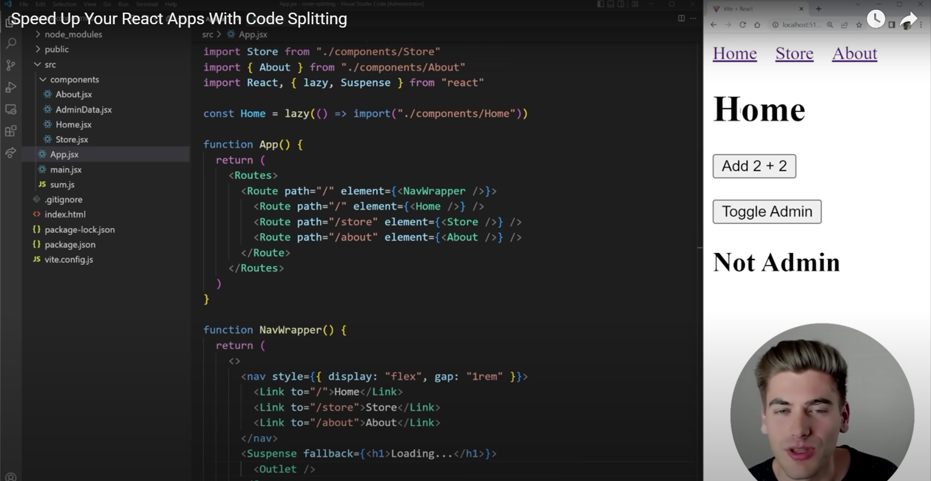

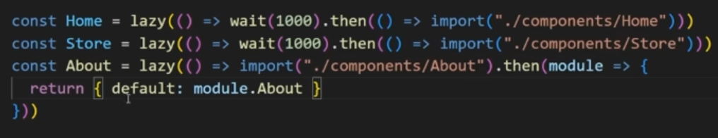

**Lazy loading works with useTransition Hook**

**My assumption is that AdminData should be lazily loaded only when isAdmin is set to true, assuming the last render was our initial render.**

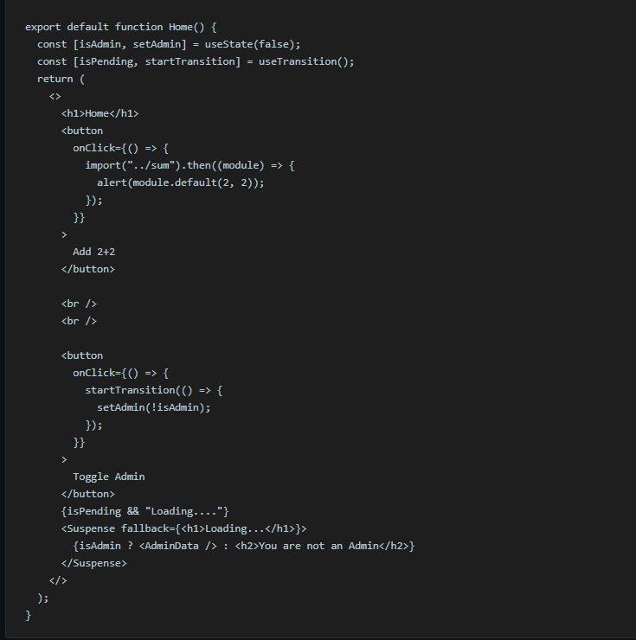

Recommended Way For Lazy loading

